Evening Layout

## During Evening Reset Period

1. Check PA is setup ready for sound check
2. Setup 30 seats around outside edge for those less able to stand
3. Stack remaining chairs that have been left around the tent during the afternoon (MAX 10 high)
4. Ensured pallet chairs outside with are covered with Tarp
5. Close tent doors ready for evening opening
6. Take offering pots from storage area and place them by stage
7. Power Mixer
8. Turn on lights
9. Ensure 4 chairs are setup behind screen for deliverance, if needed
10. Ensure there is a stand mic on the stage

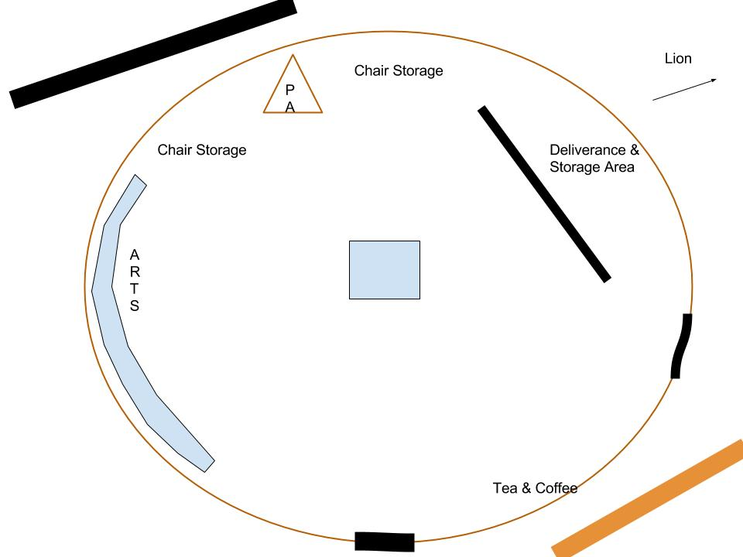

## After Evening Service

1. Pack away mics etc
2. Power off mixer
3. Turn off lights
4. Brief Security Guards
5. Hand Over Keys
6. Secure Tent
7. Place collection pots behind screen in storage area
8. Collect badges and lanyards